**Vanier College**

**Faculty of Science and Technology**

**System Development 420-436-VA**

Deliverable 01

**Grey Team**

Gennaro Finelli

Mohammed Hosein Ali

Alexandre Pham

Wayne De Leon

In collaboration with CyberStation

**(Code from our eCommerce class will be used for certain features of this project)**

**We, the Grey Team, certify that this assignment is our own work**

I, Gennaro Finelli, student ID# 2268107, certify that I have contributed to this deliverable, G.F

I, Mohammed Hosein Ali, student ID# 2055295, certify that I have contributed to this deliverable, M.H.A

I, Alexandre Pham, student ID# 2048017, certify that I have contributed to this deliverable, A.P

I, Wayne De Leon, student ID# 2179710, certify that I have contributed to this deliverable, W.D

Contents

Executive Overview 3

Client/Sponsor 4

Team Organization 5

Meeting Schedule 5

Repositories 5

Communication 5

Synchronous Meetings 6

Areas of Responsibility 6

Contact Information 6

Client Contact 7

Reports 7

Project Plan 8

# Executive Overview

The project being presented is a prototype eCommerce web application for a client. Our client, Sara Chahrour, is a small business order located in Montreal. She offers a gaming station for people to pass time while waiting for their flight. To achieve this eCommerce web application prototype, our team has to organize weekly meetings in-person and online (as seen in Meeting Schedule). In these meetings, team members will have to discuss the current status of the project, the planning, and the separation of tasks between team members. Regular meetings with our client will also be part of the process to keep up with any changes the client would like to have done, and to update the client on the current status of the project. As of now, the main client contact for exchanging communication with the client is going to be Mohammed Hosein Ali.

Our team will be using Discord as our communication method. Github will be used to share documents and files between our team. Our project’s plan will be tracked using our chart made on Microsoft Project detailing each task, its estimated work time, start/end dates, the sequencing, and their assigned members. (see Project Plan).

As per the general project instructions, a new team leader will be assigned for each deliverable. Each task will also be assigned based on each team member’s capabilities and strengths. Although some responsibilities will not be passed around by team members, such as the minutes reports as well as client communications, will remain the responsibilities of a singular member throughout the project to keep a clean and consistent set of notes of our progress.

# Client/Sponsor

Our client’s name is Sarah Chahrour, she is currently running a gaming lounge located in the airport called, CyberStation, where she provides a gaming station for customers to pass time as they wait for their flights. She offers times for customers to book a gaming station for a set amount of time.

Our client does not have any computer/programming skills. She will not be the only one able to access the project we make; her workers will also have access to view the project we develop.

Our client’s main business problem is handling reservations. She needs a web application that allows potential customers to book a certain time period, if a station is available, and she needs to be able to view every reservation made. She also wants the customers to be able to pay for the station ahead of time, through our web application.

# Team Organization

## Meeting Schedule

Our team’s meeting schedule is as follows:

* Tuesday in Class: 13:00 – 16:00
* Thursday in Class: 12:00 – 16:00
* Discord meeting online: after class hours (Optional)

## Repositories

Our team is working on Github. We have chosen Github because it allows for multiple files to be shared and worked on at the same time with constant updates and details about those updates. The github repository is linked below.

* Github: <https://github.com/apalex/sys-dev-project>
* Below are our names next to our Github usernames:
  + Gennaro Finelli: gennarofinelli
  + Mohammed H. Ali: iS1ngforU
  + Alexandre Pham: apalex
  + Wayne De Leon: 2179710

## Communication

Our team will be communicating exclusively via discord. Discord is a very convenient communications platform where we will be able to share files and exchange messages. The team members of this assignment all agree it is the most comfortable platform for us to use. The policies we have set up are:

* Follow the schedule
* Respect other team members:
* Do not speak over someone else
* Remain open minded
* Don’t be rude

## 

## Synchronous Meetings

Our synchronous meetings that include all team members are written in the Meeting Schedule part in this document. Our synchronous meetings will be mostly in class during Tuesdays and Thursdays. The reason for this is we would have better communication in person, and it fits our schedule for the week. Also, it would be very helpful to work on our project in class so we could ask our professors some questions if we encounter problems. If our work is not done and our time is not enough, we have an option to meet online through discord.

We will be having synchronous meetings with the Client and the schedule will depend on the Client’s schedule. Our main point of contact with the Client is *Mohammed,* as his job is in the Client’s gaming lounge. Then Mohammed will communicate with the team to voice out the Client’s needs.

## Areas of Responsibility

Most of our work on the project is divided equally. Some responsibilities may change as we work further.

* Mohammed will be the team’s main contact person between our client and our team. The reason being is because he works for the client in her gaming lounge, so he knows and meets the client more than the group.

The work that is in rotation will be mostly on the team leader.

* The responsibility is that the team leader will work on the team logbook so that each member of the team experiences team organization and keep each member aware of the project’s progression.

## Contact Information

* Alexandre Pham: [alexpham2003@gmail.com](mailto:alexpham2003@gmail.com) | 5147093551
* Gennaro Finelli: [gennarofinelli05@gmail.com](mailto:gennarofinelli05@gmail.com) | 5146492232
* Wayne De Leon: [wayned0527@gmail.com](mailto:wayned0527@gmail.com) | 4384060527
* Mohammed H. Ali: [m.hali2002@hotmail.com](mailto:m.hali2002@hotmail.com) | 2055295

## Client Contact

There will only be one contact with the client: our main contact for the client will be Mohammed, due to him being the one to have found our client and he already has a professional relationship since she is his boss. The main source of contact with our client will be done through SMS.

* Phone: 5146384311
* Email: [sara.chahrour@hotmail.com](mailto:sara.chahrour@hotmail.com)

## Reports

In our group, the team agreed that the best way to finish each deliverable goes:

* We will have a short meeting to talk about the work and divide tasks.
* The team leader would look into the tasks done if each member did their tasks.
* The team leader would make the members sign the documents for deliverables.
* Wayne De Leon will review each deliverable for missing content and design flaws.
* The team leader will do one final review of the deliverable before all members can submit.

# Project Plan

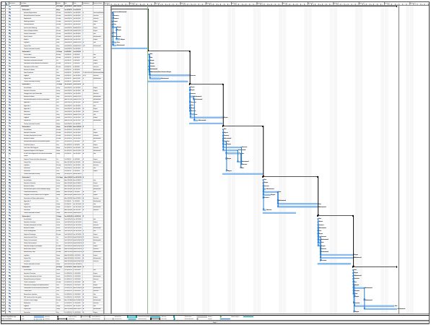

[Click here to view the PDF file](../../Documents/ProjectPlan.pdf)